Chapter 15, Problem 5.

Find the Laplace transform of each of the following functions:

- t² cos(2t + 30°)u(t) (b) 3t⁴ e^{-2t} u(t)
(c) 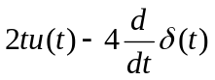 (d) 2e^{-(t-1)} u(t)
(e) 5u(t/2) (f) 6e^{-t/3} u(t)
(f) 